DIAGRAMA DE FLUJO

MICROCONTROLADOR 16F887

POTENCIOMETRO

BATERIA

RASPBERRY PI

ANTENA LCD

USB SERIAL

DIAGRAMA DE CONEXIÓN

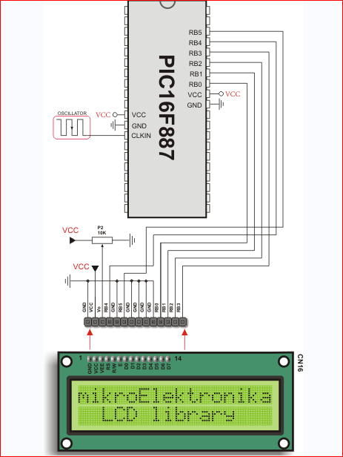

SIMULACION DEL CIRCUITO

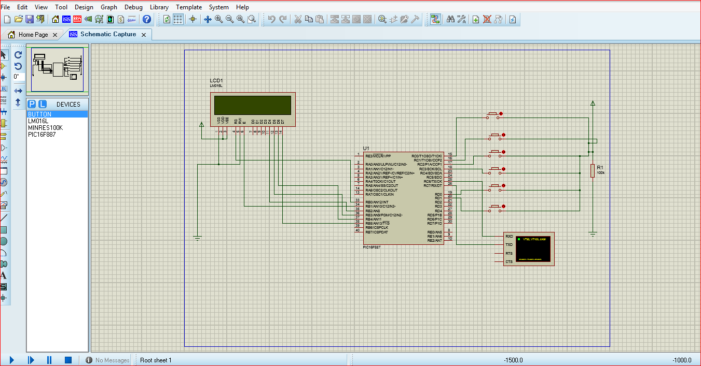

INICIO DEL PROGRAMA

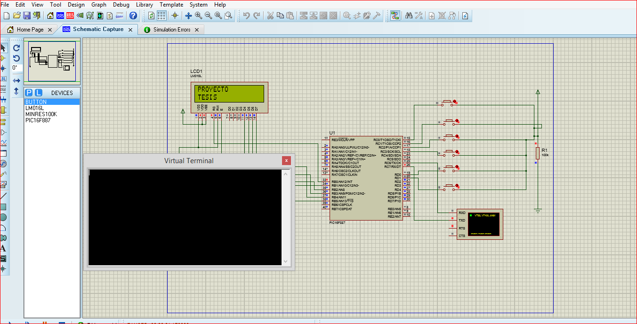

ETAPA DE NOMBRAMIENTO

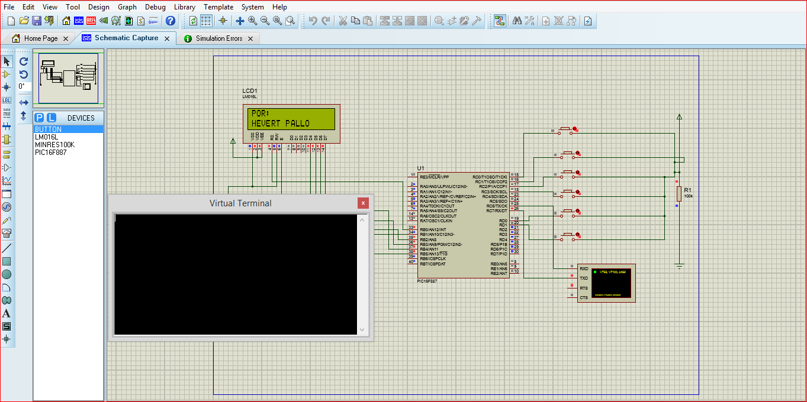

ETAPA DE LECTURA

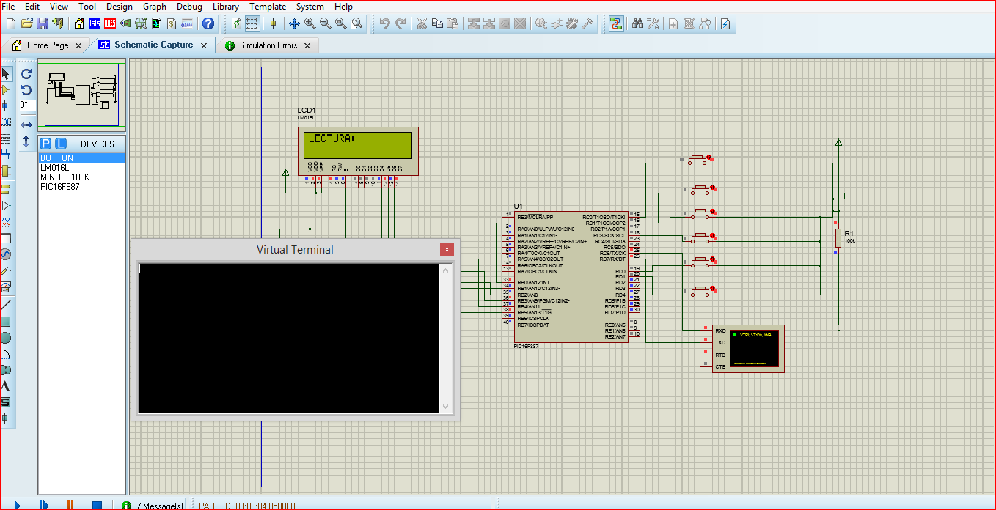

ETAPA DE MUESTRA DE DATOS

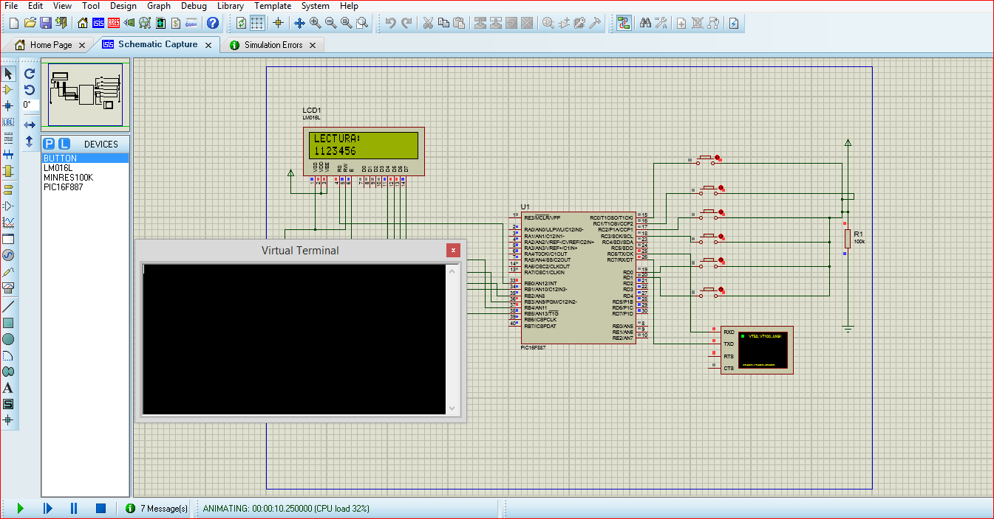

PCB

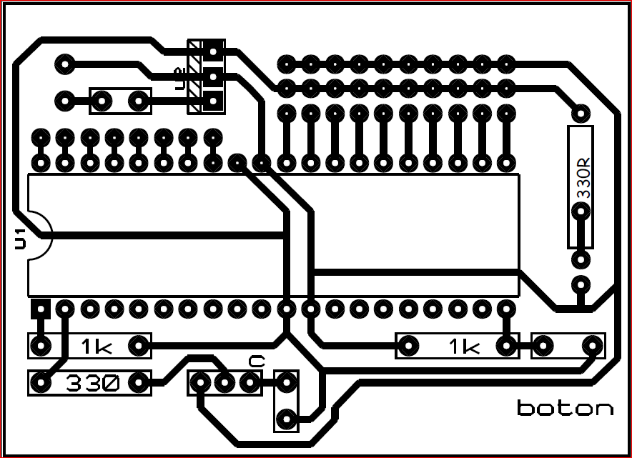

DESAARROLLO DE PLACA

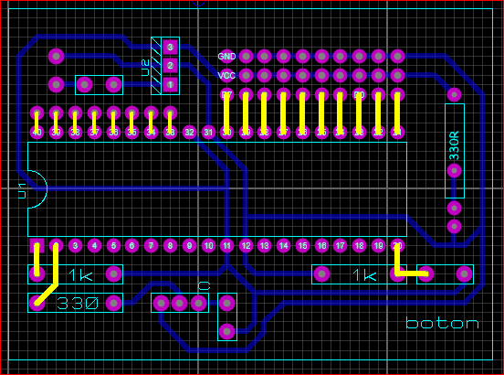

VISTA EN 3D

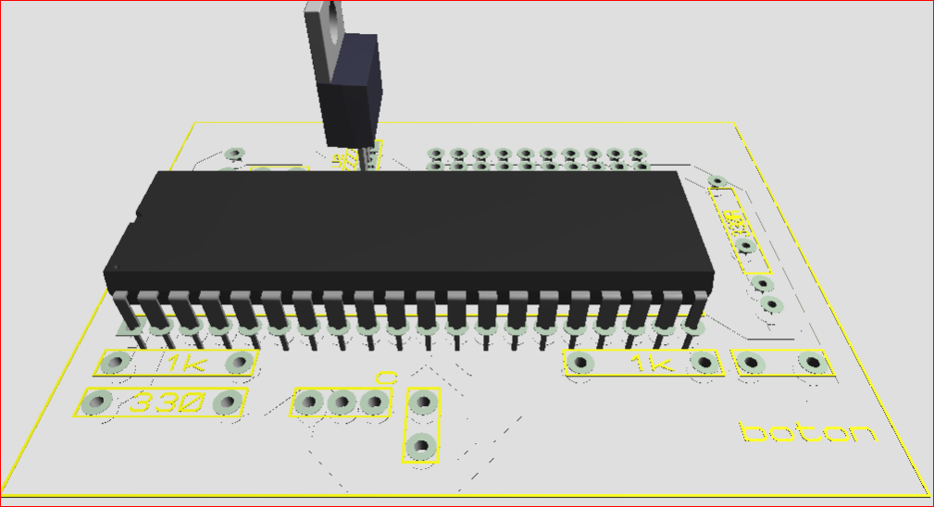

VISTA FRONTAL

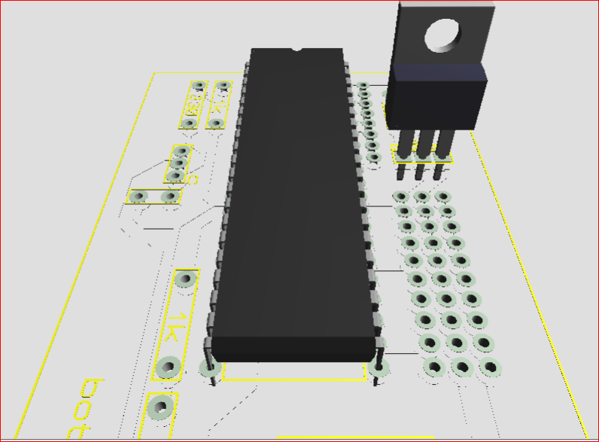

MIKROBASIC

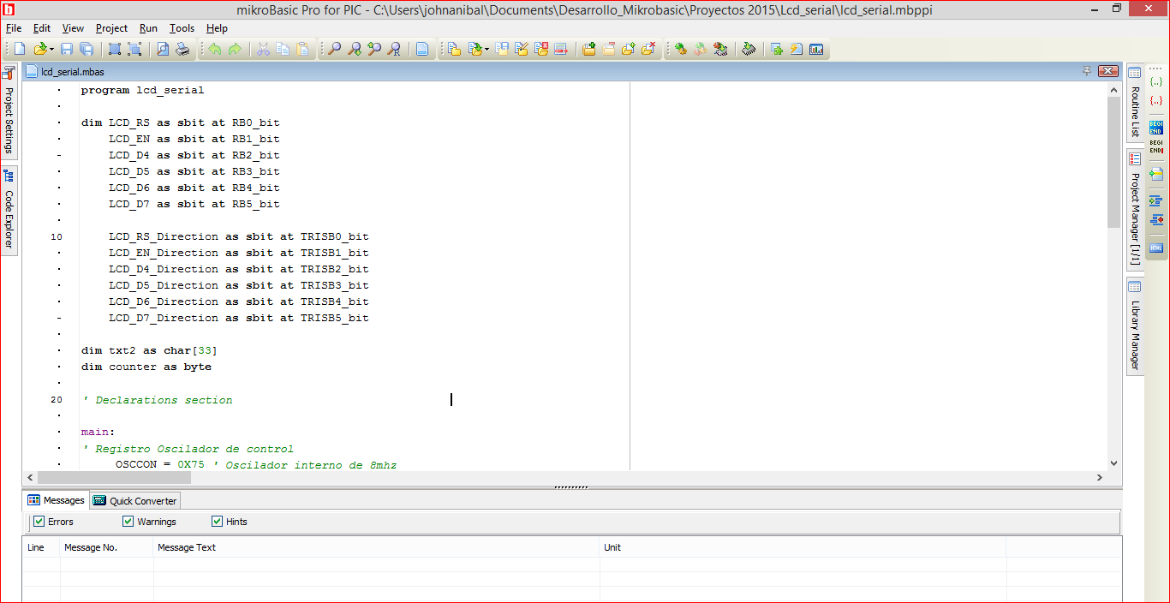

PROGRAMACION DEL PIC

program lcd_serial

dim LCD_RS as sbit at RB0_bit

LCD_EN as sbit at RB1_bit

LCD_D4 as sbit at RB2_bit

LCD_D5 as sbit at RB3_bit

LCD_D6 as sbit at RB4_bit

LCD_D7 as sbit at RB5_bit

LCD_RS_Direction as sbit at TRISB0_bit

LCD_EN_Direction as sbit at TRISB1_bit

LCD_D4_Direction as sbit at TRISB2_bit

LCD_D5_Direction as sbit at TRISB3_bit

LCD_D6_Direction as sbit at TRISB4_bit

LCD_D7_Direction as sbit at TRISB5_bit

dim txt2 as char[33]

dim counter as byte

' Declarations section

main:

' Registro Oscilador de control

OSCCON = 0X75 ' Oscilador interno de 8mhz

' Registro PUERTO A

TRISA = 0X00 ' PORTA.0 Entrada

PORTA = 0X00

' Registro PUERTO B

TRISB = 0X00 ' PORTB salidas

PORTB = 0X00

' Registro PUERTO C

TRISC = 0XFF ' PORTC salidas

PORTC = 0X00

' Registro PUERTO D

TRISD = 0X03 ' PORTE como salidas digital

PORTD = 0X00

' Seleccion de registro analogico. 1 analogico, 0 digitales

ANSEL = 0X00 ' AN<7:0>

ANSELH = 0X00 ' AN<13:8>

Lcd_Init() ' Inicializacion Lcd

Lcd_Cmd(_LCD_CLEAR) ' encera display

Lcd_Cmd(_LCD_CURSOR_OFF) ' Cursor off

Lcd_Out(1,1,"PROYECTO ") ' escribe la cadena en la primera fila

Lcd_Out(2,1,"TESIS ") ' escribe la cadena en la segunda fila

delay_ms(2000)

Lcd_Cmd(_LCD_CLEAR) ' encera display

Lcd_Out(1,1,"POR:") ' escribe la cadena en la primera fila

Lcd_Out(2,1,"HEVERT PALLO") ' escribe la cadena en la segunda fila

delay_ms(2000)

Lcd_Cmd(_LCD_CLEAR) ' encera display

delay_ms(250)

UART1_Init(9600)

Lcd_Out(1,1,"LECTURA:") ' escribe la cadena en la primera fila

while(1)

if (UART1_Data_Ready() <> 0) then ' If data is received,

UART1_Read_Text(txt2,"-",32) ' lee la cadena hasta que encuentre la letra K mayuscula

Lcd_Cmd(_LCD_CLEAR) ' encera display

Lcd_Out(1,1,"LECTURA:") ' escribe la cadena en la primera fila

Lcd_Out(2,1,txt2)

end if

wend

end.